Windows User

[Email address]

Naeem Bux [213003775]

Requirements Document for game application called Quiz Master.

Development SOftware 4[Dos400s]

Create a Serious Game

Quiz Master

# Introduction

Quiz Master is a game built for all ages.

The game focuses on asking a general knowledge question, giving you 3 attempts to find the correct answer. There are three difficulty levels. Easy, Medium, and Hard. Each difficulty setting specifies the number of questions that is made available. The game can be either set to be sequential or randomized.

## Game overview

The game for all ages, you start up the game. You’re taken to the home screen.

Once at the home screen you click the start button to begin a new game.

You are then prompted to enter a username. This name will be used when storing any scores.

Once you have entered your desired username, a welcome message appears with instructional text on how to play the game appears.

Once you’re ready, you may click the Begin button to have words start being served to you (the user). The user enters answers based on the question received, the user is given 3 attempts, at the end of which the game will end, and shut down.

For each correct answer the users receives 3 points, however, if a loser gets a question incorrect. The number of points given for each correctly answered question has been reduced.

A user can however, skip the question they’re currently attempting, without penalty. However, this can only be done once.

## Functional Requirements.

* User should easily navigate the Graphical User Interface(GUI).
* User must click start.
* Data is loaded from multiple text files to populate question and answer lists.
* Text Boxes display instructions for user.
* User must read the instructions.
* User may view existing scores.
* User must click begin.
* Start button is disabled.
* High scores is disabled.
* TextBox (questionTxt) is populated with the question
* Textbox (answerTxt) is left open to answer provided question.
* User must answer correctly within 3 attempts, else the game ends.
* User may click next, to switch to a new question. The user only has 1 attempt at swapping a question at a time.
* Once game ends, scores are written to a text file.

## Non Functional Requirements

### Operating Constraints:

* The game is run by executing the associated JAR file, labelled “BSG.jar”.
* The game requires 110KB storage space.
* The file can be placed anywhere on the file system, and can be run from a flash drive.

### System Constraints:

* The program has very small requirements.
* Less than 1GB RAM is sufficient as well as 10MB of storage space to facilitate future upgrades.
* This game can be run using the most standard and on board graphics cards.
* The game has been tested can support Windows XP, 7, 8, and 10.
* The game has not been tested on any other operating platform.

### Possible Modifications:

* The Question and Answer bank can be updated by adding new questions to the file (“Questions.txt”) and new answers to the file (“Answers.txt”).
* The difficulty setting can be adjusted between 3 levels.
  + Easy provides 5 questions.
  + Normal provides 10 questions.
  + Hard provides 15 questions.
* At a programming level:
  + Number of questions available between difficulty settings is modifiable.
  + Number of lives is modifiable.
  + Number of questions to be skipped is modifiable.

## Proposed System Requirements

Proposed requirements and specifications for future release:

* Implement images for correct & incorrect answers.
* Implement reset button to reset game.
* Increase number of questions.
* Modify storage system to implement a database.
* Implement feature to randomize questions instead of having questions served sequentially.
* Change layout type for ease of modification.

## Use Case Diagram

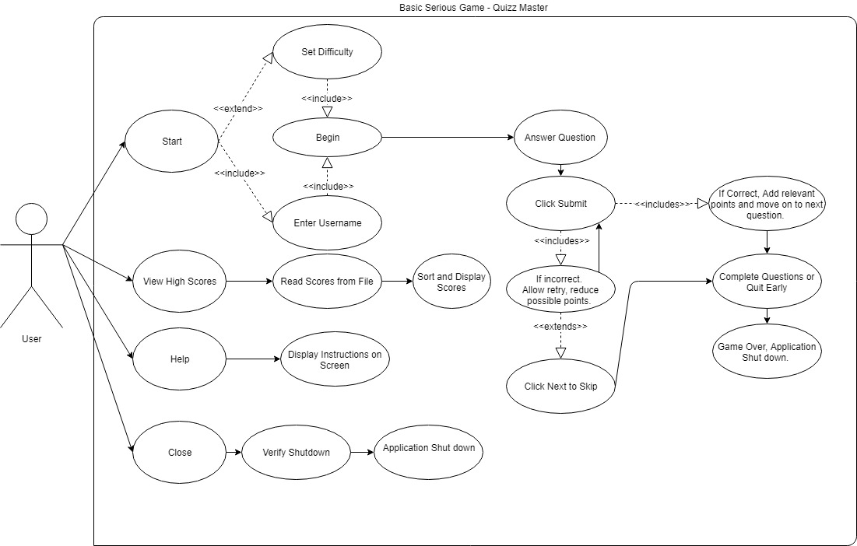

## Entity Relationship Diagram/UML

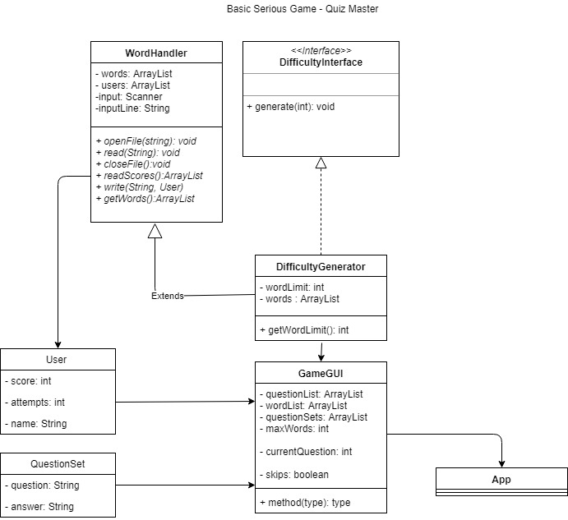

## Screens (Visual Aid)

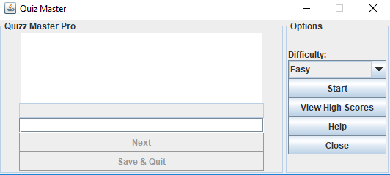

The initial screen, this is the first screen viewed when application starts up.

### View High Scores:

#### Step 1

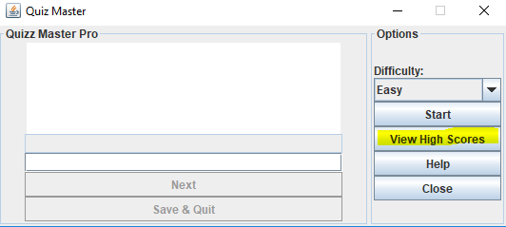

Click the View High Scores Button, highlighted above to view saved score in descending order from highest to the lowest.

#### Step 2

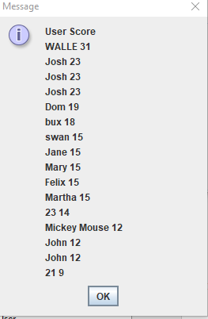

Click okay to return to the home screen.

### Starting up

#### Step 1: Select a difficulty

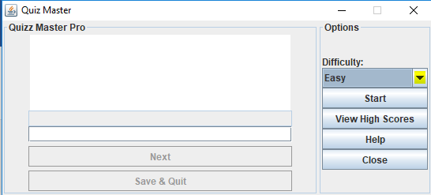

Click the drop down box to adjust game difficulty.

There are 3 Settings: Easy, Normal, Hard.

Easy – 5 questions

Normal – 10 questions

Hard – 15 questions

#### Step 2: Initialize Game Session

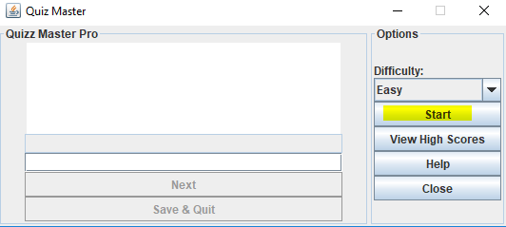

Click the start button to initiate a game session.

#### Step 3: Enter a username

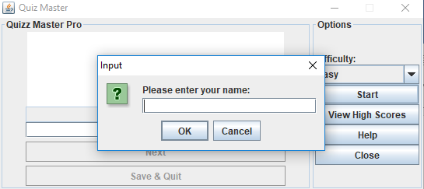

Enter a username for the player, and click okay.

#### Step 4: The Welcome Screen

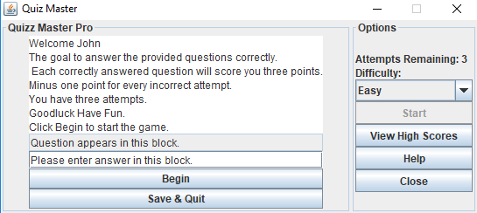

Game session has been initialized, instructions are displayed.

Click Begin to start the game.

#### Step 5: The Game

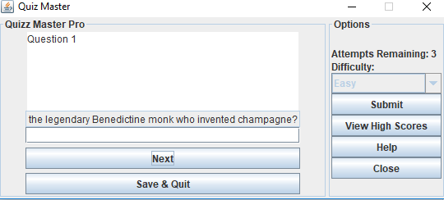

After clicking start the first question appears.

Click Next to skip question.

Click Submit to save answer.

Note: You may skip one question every turn. Submit a correct answer to end the turn.

#### Step 6.1: Answering a question correctly.

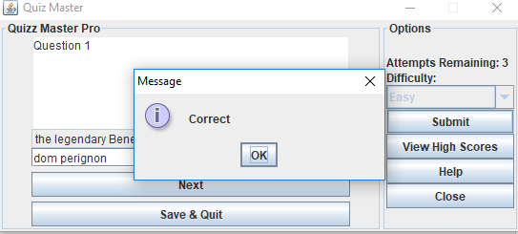

If you click submit, and the answer is correct.

You will receive the above notification. And the next question will be displayed.

#### Step 6.2: Answering a question incorrectly.

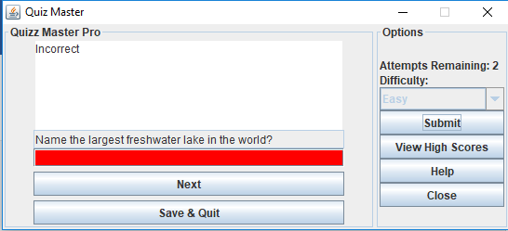

If you click submit, and the answer is incorrect.

The answer box will highlight red, and you will have 2 remaining attempts to answer the question.

You may skip the question once.

Note: Points will be reduced by 1 every time an answer is incorrectly supplied.

#### Step 7: Save and Quit

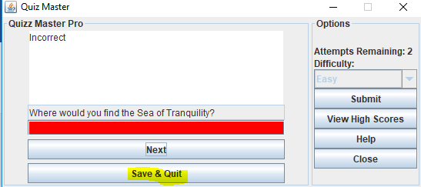

Click Save & Quit to end the game prematurely and save your current score.

The application will terminate.

#### Step 7.2: Save & Quit

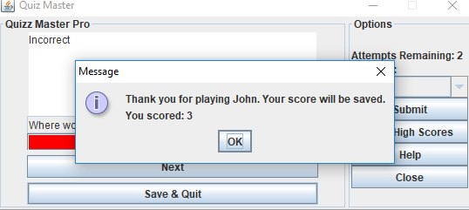

You will receive a notification, indicating your current score.

After clicking OK. The application will terminate.

### Close

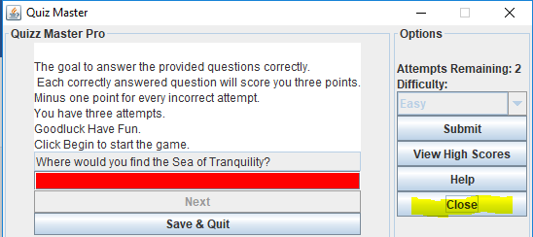

Click close to terminate the game without saving data.

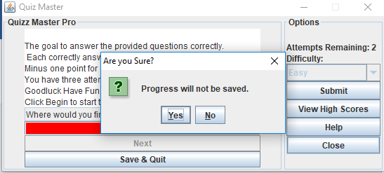

Click Yes to terminate the application, and no to return to the previous screen.

### Help

#### Step 1: Click Help

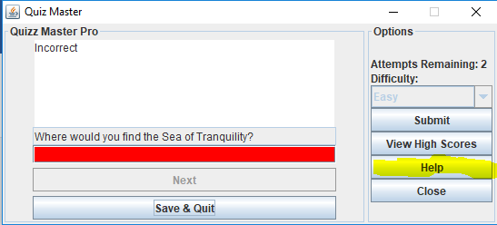

Click help to display instructions again.

